41.45: 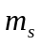 can take on 4 different values: 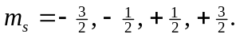 Each 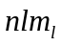 state can have 4 electrons, each with one of the four different values.
a) For a filled 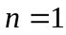 shell, the electron configuration would be 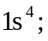 four electrons and 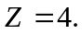 For a filled 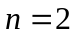 shell, the electron configuration would be 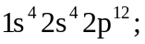 twenty electrons and 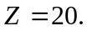
b) Sodium has 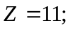 11 electrons. The ground-state electron configuration would be 